**Cryptography And Network Security Lab**

**Assignment submission**

**PRN No: 2019BTECS00017**

**Full name: Muskan Raju Attar**

**Batch: B5**

**Assignment: 6**

**Title of assignment: Implementation of DES – Data Encryption Standard**

**Title:**

Implementation of Data Encryption Standard

**Aim:**

To develop and implement the Data Encryption Standard and to do encryption and decryption on the input plaintext

**Theory:**

* The Data Encryption Standard (DES) is a symmetric key block cipher published by National Institute of Standard and Technology (NIST)
* DES is an implementation of a Feistel Cipher. It uses 16 round Feistel structure.
* DES is a block cipher and encrypts data in blocks of size of 64 bits each
* 64 bits of plain text go as the input to DES, which produces 64 bits of ciphertext.
* Though, key length is 64-bit, DES has an effective key length of 56 bits, since 8 of the 64 bits of the key are not used by the encryption algorithm

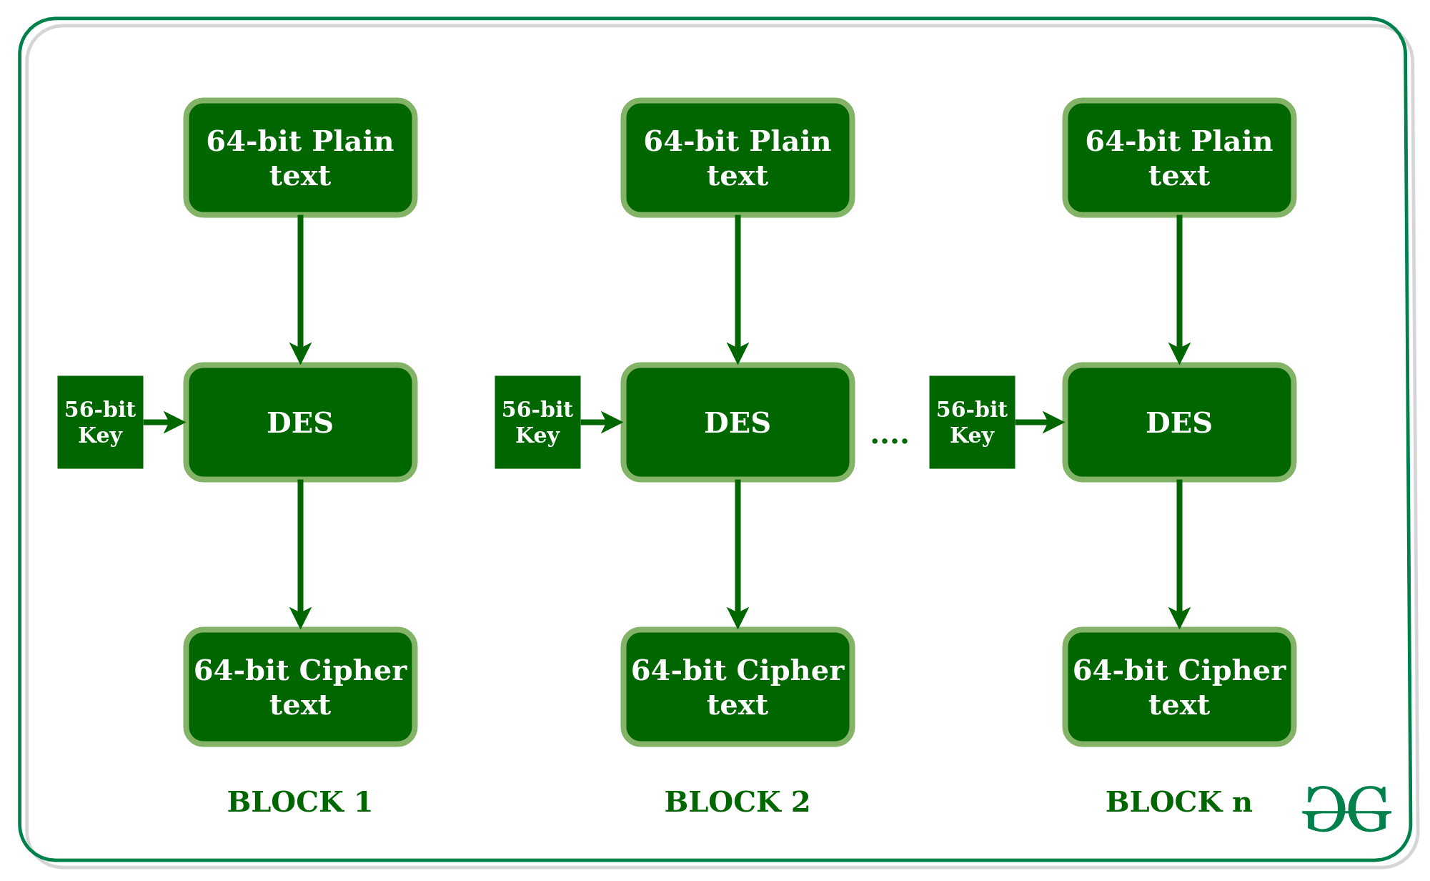

* Since DES is based on the Feistel Cipher, all that is required to specify DES is
* Round function
* Key schedule
* Any additional processing − Initial and final permutation

**Implementation of Data Encryption Standard**

**Code:**

// C++ code for the above approach

#include <bits/stdc++.h>

using namespace std;

string hex2bin(string s)

{

// hexadecimal to binary conversion

unordered_map<char, string> mp;

mp['0'] = "0000";

mp['1'] = "0001";

mp['2'] = "0010";

mp['3'] = "0011";

mp['4'] = "0100";

mp['5'] = "0101";

mp['6'] = "0110";

mp['7'] = "0111";

mp['8'] = "1000";

mp['9'] = "1001";

mp['A'] = "1010";

mp['B'] = "1011";

mp['C'] = "1100";

mp['D'] = "1101";

mp['E'] = "1110";

mp['F'] = "1111";

string bin = "";

for (int i = 0; i < s.size(); i++) {

bin += mp[s[i]];

}

return bin;

}

string bin2hex(string s)

{

// binary to hexadecimal conversion

unordered_map<string, string> mp;

mp["0000"] = "0";

mp["0001"] = "1";

mp["0010"] = "2";

mp["0011"] = "3";

mp["0100"] = "4";

mp["0101"] = "5";

mp["0110"] = "6";

mp["0111"] = "7";

mp["1000"] = "8";

mp["1001"] = "9";

mp["1010"] = "A";

mp["1011"] = "B";

mp["1100"] = "C";

mp["1101"] = "D";

mp["1110"] = "E";

mp["1111"] = "F";

string hex = "";

for (int i = 0; i < s.length(); i += 4) {

string ch = "";

ch += s[i];

ch += s[i + 1];

ch += s[i + 2];

ch += s[i + 3];

hex += mp[ch];

}

return hex;

}

string permute(string k, int* arr, int n)

{

string per = "";

for (int i = 0; i < n; i++) {

per += k[arr[i] - 1];

}

return per;

}

string shift_left(string k, int shifts)

{

string s = "";

for (int i = 0; i < shifts; i++) {

for (int j = 1; j < 28; j++) {

s += k[j];

}

s += k[0];

k = s;

s = "";

}

return k;

}

string xor_(string a, string b)

{

string ans = "";

for (int i = 0; i < a.size(); i++) {

if (a[i] == b[i]) {

ans += "0";

}

else {

ans += "1";

}

}

return ans;

}

string encrypt(string pt, vector<string> rkb,

vector<string> rk)

{

// Hexadecimal to binary

pt = hex2bin(pt);

// Initial Permutation Table

int initial_perm[64]

= { 58, 50, 42, 34, 26, 18, 10, 2, 60, 52, 44,

36, 28, 20, 12, 4, 62, 54, 46, 38, 30, 22,

14, 6, 64, 56, 48, 40, 32, 24, 16, 8, 57,

49, 41, 33, 25, 17, 9, 1, 59, 51, 43, 35,

27, 19, 11, 3, 61, 53, 45, 37, 29, 21, 13,

5, 63, 55, 47, 39, 31, 23, 15, 7 };

// Initial Permutation

pt = permute(pt, initial_perm, 64);

cout << "After initial permutation: " << bin2hex(pt)

<< endl;

// Splitting

string left = pt.substr(0, 32);

string right = pt.substr(32, 32);

cout << "After splitting: L0=" << bin2hex(left)

<< " R0=" << bin2hex(right) << endl;

// Expansion D-box Table

int exp_d[48]

= { 32, 1, 2, 3, 4, 5, 4, 5, 6, 7, 8, 9,

8, 9, 10, 11, 12, 13, 12, 13, 14, 15, 16, 17,

16, 17, 18, 19, 20, 21, 20, 21, 22, 23, 24, 25,

24, 25, 26, 27, 28, 29, 28, 29, 30, 31, 32, 1 };

// S-box Table

int s[8][4][16] = {

{ 14, 4, 13, 1, 2, 15, 11, 8, 3, 10, 6, 12, 5,

9, 0, 7, 0, 15, 7, 4, 14, 2, 13, 1, 10, 6,

12, 11, 9, 5, 3, 8, 4, 1, 14, 8, 13, 6, 2,

11, 15, 12, 9, 7, 3, 10, 5, 0, 15, 12, 8, 2,

4, 9, 1, 7, 5, 11, 3, 14, 10, 0, 6, 13 },

{ 15, 1, 8, 14, 6, 11, 3, 4, 9, 7, 2, 13, 12,

0, 5, 10, 3, 13, 4, 7, 15, 2, 8, 14, 12, 0,

1, 10, 6, 9, 11, 5, 0, 14, 7, 11, 10, 4, 13,

1, 5, 8, 12, 6, 9, 3, 2, 15, 13, 8, 10, 1,

3, 15, 4, 2, 11, 6, 7, 12, 0, 5, 14, 9 },

{ 10, 0, 9, 14, 6, 3, 15, 5, 1, 13, 12,

7, 11, 4, 2, 8, 13, 7, 0, 9, 3, 4,

6, 10, 2, 8, 5, 14, 12, 11, 15, 1, 13,

6, 4, 9, 8, 15, 3, 0, 11, 1, 2, 12,

5, 10, 14, 7, 1, 10, 13, 0, 6, 9, 8,

7, 4, 15, 14, 3, 11, 5, 2, 12 },

{ 7, 13, 14, 3, 0, 6, 9, 10, 1, 2, 8, 5, 11,

12, 4, 15, 13, 8, 11, 5, 6, 15, 0, 3, 4, 7,

2, 12, 1, 10, 14, 9, 10, 6, 9, 0, 12, 11, 7,

13, 15, 1, 3, 14, 5, 2, 8, 4, 3, 15, 0, 6,

10, 1, 13, 8, 9, 4, 5, 11, 12, 7, 2, 14 },

{ 2, 12, 4, 1, 7, 10, 11, 6, 8, 5, 3, 15, 13,

0, 14, 9, 14, 11, 2, 12, 4, 7, 13, 1, 5, 0,

15, 10, 3, 9, 8, 6, 4, 2, 1, 11, 10, 13, 7,

8, 15, 9, 12, 5, 6, 3, 0, 14, 11, 8, 12, 7,

1, 14, 2, 13, 6, 15, 0, 9, 10, 4, 5, 3 },

{ 12, 1, 10, 15, 9, 2, 6, 8, 0, 13, 3, 4, 14,

7, 5, 11, 10, 15, 4, 2, 7, 12, 9, 5, 6, 1,

13, 14, 0, 11, 3, 8, 9, 14, 15, 5, 2, 8, 12,

3, 7, 0, 4, 10, 1, 13, 11, 6, 4, 3, 2, 12,

9, 5, 15, 10, 11, 14, 1, 7, 6, 0, 8, 13 },

{ 4, 11, 2, 14, 15, 0, 8, 13, 3, 12, 9, 7, 5,

10, 6, 1, 13, 0, 11, 7, 4, 9, 1, 10, 14, 3,

5, 12, 2, 15, 8, 6, 1, 4, 11, 13, 12, 3, 7,

14, 10, 15, 6, 8, 0, 5, 9, 2, 6, 11, 13, 8,

1, 4, 10, 7, 9, 5, 0, 15, 14, 2, 3, 12 },

{ 13, 2, 8, 4, 6, 15, 11, 1, 10, 9, 3, 14, 5,

0, 12, 7, 1, 15, 13, 8, 10, 3, 7, 4, 12, 5,

6, 11, 0, 14, 9, 2, 7, 11, 4, 1, 9, 12, 14,

2, 0, 6, 10, 13, 15, 3, 5, 8, 2, 1, 14, 7,

4, 10, 8, 13, 15, 12, 9, 0, 3, 5, 6, 11 }

};

// Straight Permutation Table

int per[32]

= { 16, 7, 20, 21, 29, 12, 28, 17, 1, 15, 23,

26, 5, 18, 31, 10, 2, 8, 24, 14, 32, 27,

3, 9, 19, 13, 30, 6, 22, 11, 4, 25 };

cout << endl;

for (int i = 0; i < 16; i++) {

// Expansion D-box

string right_expanded = permute(right, exp_d, 48);

// XOR RoundKey[i] and right_expanded

string x = xor_(rkb[i], right_expanded);

// S-boxes

string op = "";

for (int i = 0; i < 8; i++) {

int row = 2 * int(x[i * 6] - '0')

+ int(x[i * 6 + 5] - '0');

int col = 8 * int(x[i * 6 + 1] - '0')

+ 4 * int(x[i * 6 + 2] - '0')

+ 2 * int(x[i * 6 + 3] - '0')

+ int(x[i * 6 + 4] - '0');

int val = s[i][row][col];

op += char(val / 8 + '0');

val = val % 8;

op += char(val / 4 + '0');

val = val % 4;

op += char(val / 2 + '0');

val = val % 2;

op += char(val + '0');

}

// Straight D-box

op = permute(op, per, 32);

// XOR left and op

x = xor_(op, left);

left = x;

// Swapper

if (i != 15) {

swap(left, right);

}

cout << "Round " << i + 1 << " " << bin2hex(left)

<< " " << bin2hex(right) << " " << rk[i]

<< endl;

}

// Combination

string combine = left + right;

// Final Permutation Table

int final_perm[64]

= { 40, 8, 48, 16, 56, 24, 64, 32, 39, 7, 47,

15, 55, 23, 63, 31, 38, 6, 46, 14, 54, 22,

62, 30, 37, 5, 45, 13, 53, 21, 61, 29, 36,

4, 44, 12, 52, 20, 60, 28, 35, 3, 43, 11,

51, 19, 59, 27, 34, 2, 42, 10, 50, 18, 58,

26, 33, 1, 41, 9, 49, 17, 57, 25 };

// Final Permutation

string cipher

= bin2hex(permute(combine, final_perm, 64));

return cipher;

}

// Driver code

int main()

{

// pt is plain text

string pt, key;

/*cout<<"Enter plain text(in hexadecimal): ";

cin>>pt;

cout<<"Enter key(in hexadecimal): ";

cin>>key;*/

// cout << "Enter PLAIN TEXT of EXACTLY 16 character written in hexadecimal : ";

// cin >> pt;

cout << "Enter a KEY of EXACTLY 16 character written in hexadecimal : ";

cin>> key;

// pt = "123456ABCD132536";

// key = "AABB09182736CCDD";

// Key Generation

// Hex to binary

key = hex2bin(key);

// Parity bit drop table

int keyp[56]

= { 57, 49, 41, 33, 25, 17, 9, 1, 58, 50, 42, 34,

26, 18, 10, 2, 59, 51, 43, 35, 27, 19, 11, 3,

60, 52, 44, 36, 63, 55, 47, 39, 31, 23, 15, 7,

62, 54, 46, 38, 30, 22, 14, 6, 61, 53, 45, 37,

29, 21, 13, 5, 28, 20, 12, 4 };

// getting 56 bit key from 64 bit using the parity bits

key = permute(key, keyp, 56); // key without parity

// Number of bit shifts

int shift_table[16] = { 1, 1, 2, 2, 2, 2, 2, 2,

1, 2, 2, 2, 2, 2, 2, 1 };

// Key- Compression Table

int key_comp[48] = { 14, 17, 11, 24, 1, 5, 3, 28,

15, 6, 21, 10, 23, 19, 12, 4,

26, 8, 16, 7, 27, 20, 13, 2,

41, 52, 31, 37, 47, 55, 30, 40,

51, 45, 33, 48, 44, 49, 39, 56,

34, 53, 46, 42, 50, 36, 29, 32 };

// Splitting

string left = key.substr(0, 28);

string right = key.substr(28, 28);

vector<string> rkb; // rkb for RoundKeys in binary

vector<string> rk; // rk for RoundKeys in hexadecimal

for (int i = 0; i < 16; i++) {

// Shifting

left = shift_left(left, shift_table[i]);

right = shift_left(right, shift_table[i]);

// Combining

string combine = left + right;

// Key Compression

string RoundKey = permute(combine, key_comp, 48);

rkb.push_back(RoundKey);

rk.push_back(bin2hex(RoundKey));

}

int datachoice;

cout << "Data is from\n 1. Manual Entering \n 2. File \nEnter Choice: ";

cin>>datachoice;

if(datachoice == 1)

{

cout << "Enter PLAIN TEXT of EXACTLY 16 character written in hexadecimal : ";

cin >> pt;

string cipher, text;

cout << "\nEncryption:\n\n";

cipher = encrypt(pt, rkb, rk);

cout << "\nCipher Text: " << cipher << endl;

cout << "\nDecryption\n\n";

reverse(rkb.begin(), rkb.end());

reverse(rk.begin(), rk.end());

text = encrypt(cipher, rkb, rk);

cout << "\nPlain Text: " << text << endl;

}

else

{

cout<<"Enter File Name:\n";

// cin.ignore();

string file;

string str,s;

cin>>file;

fstream mf1, mf2;

mf1.open(file.c_str());

mf2.open("CipherText.txt",ios_base::out);

cout << "\nEncryption:\n\n";

if(!mf1.is_open())

cout << "Error while Opening File";

while(getline(mf1,str))

{

s = encrypt(str, rkb, rk);

mf2.write(s.data(),s.size());

}

mf1.close();

mf2.close();

cout<<"File Encrypted\n";

cout << "\nDecryption\n\n";

reverse(rkb.begin(), rkb.end());

reverse(rk.begin(), rk.end());

// fstream mf3, mf4;

mf1.open("CipherText.txt");

mf2.open("PlainText.txt",ios_base::out);

if(!mf1.is_open())

cout << "Error while Opening File";

while(getline(mf1,str))

{

s = encrypt(str, rkb, rk);

mf2.write(s.data(),s.size());

}

mf1.close();

mf2.close();

cout<<"File Decrypted";

}

return 0;

}

**Output:**

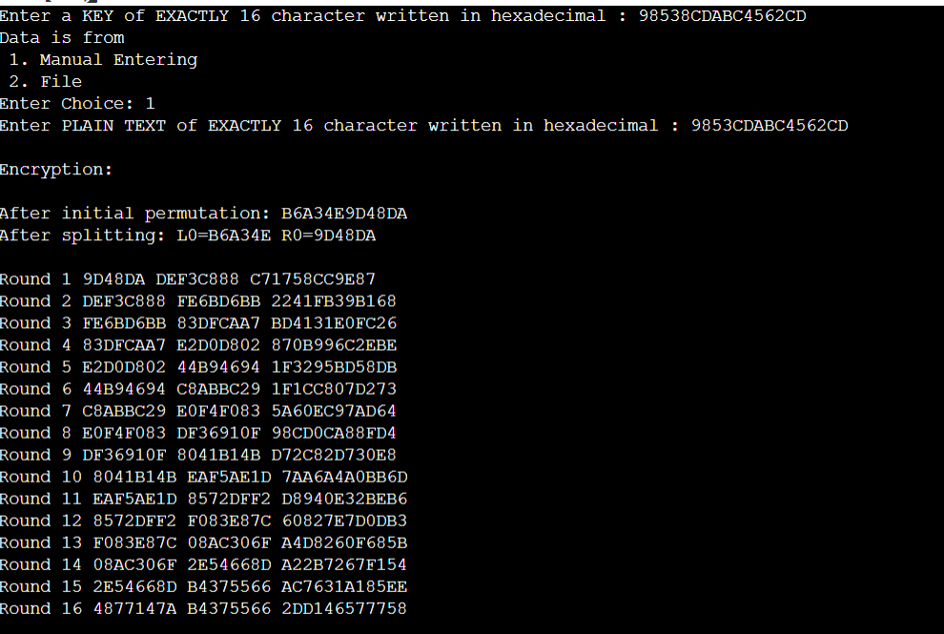

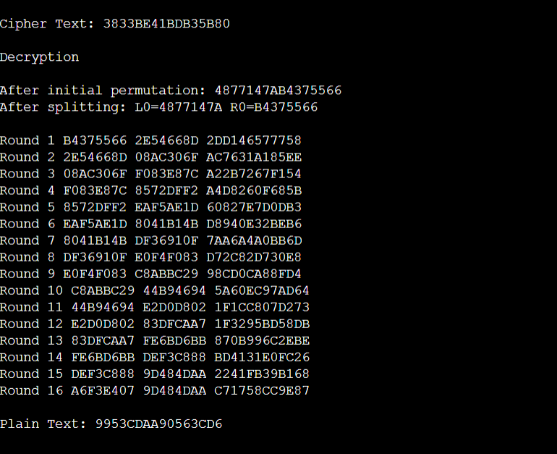

**Conclusion:**

The DES satisfies both the desired properties of block cipher. These two properties make cipher very strong.

1. Avalanche effect − A small change in plaintext results in a great change in the ciphertext.
2. Completeness − Each bit of ciphertext depends on many bits of plaintext.